Day Without Childcare FAQ
For childcare providers

Intro:
Hey <first name>, how are you? How’s it going? (Check in)
I’ve been talking to people who work in child care all across the country and there is a lot of momentum and frustration building from our elected officials’ inaction to fund child care at the level we need. Over the last couple of years coming together as Childcare Changemakers, we’ve had national days of action, shared our stories with media, held meetings with elected officials, hosted large virtual town halls but still we’re fighting for providers to make a living wage and for our communities to have the level of care that our families need. Although some politicians have heard us, many are still not taking action.

That’s why, providers right now are calling for a Day Without Child Care to send a message to those in power that we need a significant investment in childcare funding, yesterday.
What do you think about this idea? Would you be willing to join a one day action with child care providers across the country?

FAQs
I love this idea, but what will parents and families do when child care is closed for the day?
There is nothing more important than caring for our kids. That’s why we’re having conversations with providers now so that we have weeks to communicate with families about why we feel like this action is necessary. The hope is that these actions will actually lead to more subsidies for families, better care in their communities and better compensation for providers. What resources would make you feel more comfortable talking to families you work with about participating in the one day action
How will this work? I’m the only Changemaker in my community willing to do this?
There are many people just like you who are part of Changemakers. On the national day of action, we’re going to bring as many people together virtually and in person as we can. We’ll have some cities that are holding events that you could drive to if you felt comfortable. Also, we’re encouraging people to host their own events. We know when you speak out and share your stories with friends and families that you know - more people will want to show up and have your / our backs. What do you think about driving somewhere within driving distance or hosting a small event yourself? Do you know other providers and parents you could reach out to who may want to help you plan something?

I’m with y’all but I can’t afford to close down right now even for a day…
I hear that, I feel the same way. I wish we didn’t ever have to close our businesses, strike or take off from work to show how important this issue is. Historically, actions like strikes have signaled to others how serious workers have been about changing working conditions. This national day of action and solidarity strike is meant to send a message to those in power that we’re so fed up with not having the child care funding we need, that we’re willing to go without pay for one day. So, let’s talk about it - what are the things you would need to take part in this event for one day?

I work at a Child Care Center so what happens if I get fired for participating?
We’re recommending that everyone who works at a child care center has a conversation with their center director about why you feel like it’s important to participate in a “day without childcare.” Do you think your director would react positively if you explained to them that this wasn’t about speaking out against them or the center, this is about winning the investment for early education and child care that benefits everyone! What do you think their reaction would be then?

Will I get arrested?
You have a legal right to protest and raise awareness on public sidewalks, at public buildings, etc…we are not encouraging people to protest in a way that would get anyone arrested. Every event will be peaceful, non-violent actions that aim to get our message across with the sacrifice we’re all making to close our businesses or call out from work for a day. What concerns do you have that may put yourself at risk to get arrested?
How do I this with COVID still happening?
Most of our events will be taking place outside and we’re asking everyone at our events to follow CDC guidelines here. Are there specific COVID concerns you have?

Can you “strike'' if you're not a part of a union?
Yes! Non union workers have been going on strike to demand better working conditions for years. You can 100% participate in a strike even if you are not a part of a union. Have you heard of the Walmart or Fast Food strikes that happened a few years ago? They didn’t have a union either…
Can you participate if you have a child care subsidy contract?
Yes! Many childcare providers have subsidy contracts that may shape when they can close and how they can withhold labor. To navigate this, providers are being creative in how they choose to participate in the day of action. For example, if a provider gets approved paid days off, they are contacting their contractor to add/switch May 9th with one of those dates. If a provider is attending/participating in a local event, they may have a delayed opening or early dismissal planned for May 9th. If the provider wants to bring their childcare program to an event or host one at their facility, they are classifying it as a field trip or community event that can range from partial or full day participation. Some groups are arranging for pickup at a public location to enable participation from their parents and children.

What will I do with my kids?
If possible, bring them to the event! Bring 'em all! It’s important to show people who see our events who we are fighting for. How amazing would it be if there were lots of kids holding signs right there with us?

What else do I need to know?
Let’s review our event host guide and parent and provider toolkit together!

Deeper questions to discuss if “no” or “maybe” to participation:
Striking is definitely a big step - what do you think we should do to escalate on elected officials who are not with us on funding our child care? How would you send a message to them now?
What concerns do you have about going on strike or participating in the action? What do you think it’s going to take to win the childcare funding we need?

Vision / Plan to win:
We know that the laws around childcare try to divide parents and childcare workers and even pit the different types of childcare providers against each other. But that all plays into the age-old plan to divide and conquer so that nothing can actually change around this issue. What do you think will happen if parents and child care providers make national or local news uplifting this crisis by sharing their stories and showing up in solidarity with each other?

Our Movement - Our Moment: Political Update
As [parent/provider/supporter] I am/we are ready to fight for providers to be paid a living and thriving wage and for working families to have affordable, quality childcare not just to maintain our jobs but improve our quality of life and connection to our kids, families and communities. When COVID-19 shut down many other sectors, childcare providers stayed open without enough support because they cared about the families they served. Nearly 3 years later, both families and childcare workers are still facing the same issues due to the lack of investment in our childcare system. We hope for immediate passage of an economic relief package that invests in childcare and universal pre-k but Congress is still debating whether we are worth it. How do you feel about our lawmakers standing in the way of billions of dollars that could help many families right now?
.. if AFFIRMING…Well, I am right there with you! Our families can’t wait and we need to make sure our lawmakers feel the weight of their inaction. They need to carry this burden with us!
..if AGAINST… Do you think your lawmaker will do the right thing without hearing from you?

Call to Action:
Great, so glad you’re with us on participating in the strike day. The first action we’re asking everyone to take is to sign our strike pledge here: English |Spanish

Then we’re asking everyone to send a selfie photo holding a sign about why they’re interested in participating. We have a toolkit with printable graphics and templates found here.
This could be something like… “I am in solidarity with a Day Without Childcare because the kids in my community can’t afford child care” or “I’m am participating in a Day Without Childcare because I couldn’t afford child care without opening my own child care business”

We want the sign to be clear and to the point - no more than one sentence.
Next, we’re asking people to join our weekly Wednesday planning calls at 6-7 pm ET. Can you make it? RSVP at https://bit.ly/may9planning
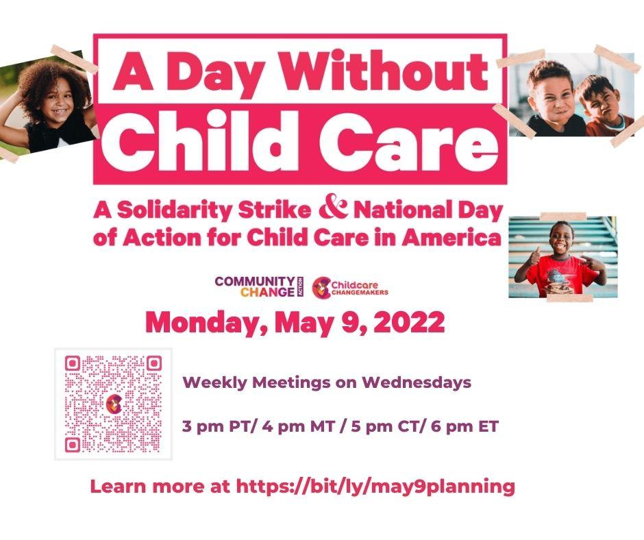
Finally, do you know other providers who would be willing to participate in our strike day too? Let’s talk about them and see if we can tag team follow up together…Tell me about them
- How do you know them?
- Where do they work?
- Why do you think they would be interested in joining?
- How do you usually communicate with them? How should we outreach to them?
- Do you think you or I should outreach to them to have a conversation about participating in the strike or is it something we should do together? Should we get together for a call?

